---

title: "Stats Project R code"

author: "Ramnath Kamakoti"

date: "August 19, 2017"

output: word_document

---

```{r}

library(haven)

X34933_0001_Data_2_ <- read_dta("C:/Users/Ramnath Kamakoti/Downloads/34933-0001-Data (2).dta")

a <-X34933_0001_Data_2_

a$ALCDAYS[a$ALCDAYS == 93] <-0

a$NODR30A[a$NODR30A == 993] <-0

a$DR5DAY[a$DR5DAY == 93] <-0

a$CA4FDDYS[a$CA4FDDYS == 93] <-0

a <- a[a$ALCDAYS < 80,]

a <- a[a$NODR30A < 900,]

a <- a[a$DR5DAY < 80,]

a <- a[a$CA4FDDYS < 80,]

a <- a[a$WORKBLAH < 80,]

```

```{r}

aov_model <- aov(a$CA4FDDYS ~ typeIncome)

summary(aov_model)

```

Df Sum Sq Mean Sq F value Pr(>F)

typeIncome 3 634 211.30 20.98 1.5e-13 ***

Residuals 12760 128531 10.07

---

Signif. codes: 0 ‘***’ 0.001 ‘**’ 0.01 ‘*’ 0.05 ‘.’ 0.1 ‘ ’ 1

```{r}

aov_model <- aov(a$CA4FDDYS ~ typeAge)

summary(aov_model)

```

Df Sum Sq Mean Sq F value Pr(>F)

typeAge 3 2540 846.6 85.31 <2e-16 ***

Residuals 12760 126626 9.9

---

Signif. codes: 0 ‘***’ 0.001 ‘**’ 0.01 ‘*’ 0.05 ‘.’ 0.1 ‘ ’ 1

```{r}

aov_model <- aov(a$CA4FDDYS ~ typeSex)

summary(aov_model)

```

Df Sum Sq Mean Sq F value Pr(>F)

typeSex 1 7327 7327 767.5 <2e-16 ***

Residuals 12762 121838 10

---

Signif. codes: 0 ‘***’ 0.001 ‘**’ 0.01 ‘*’ 0.05 ‘.’ 0.1 ‘ ’ 1

```{r}

plot(model$fitted.values, model.stres, pch = 16, main = "Standardized Residual Plot", xlab = "Fitted Values", ylab = "Standardized Residuals")

```

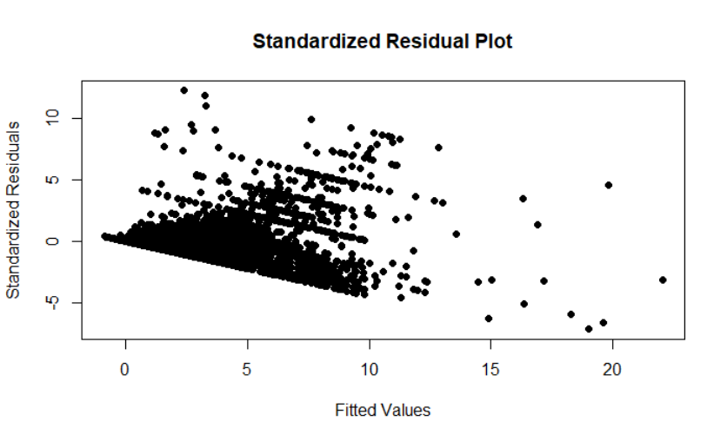

```{r}

c<-a[c("CA4FDDYS","NODR30A","ALCDAYS","WORKBLAH")]

cor(c)

```

CA4FDDYS NODR30A ALCDAYS WORKBLAH

CA4FDDYS 1.0000000 0.3794785 0.4114688 0.1451680

NODR30A 0.3794785 1.0000000 0.9353605 0.3399690

ALCDAYS 0.4114688 0.9353605 1.0000000 0.3372541

WORKBLAH 0.1451680 0.3399690 0.3372541 1.0000000